**Q. Write a prolog program to calculate the sum of two numbers.**

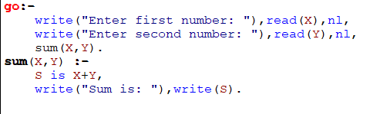

**OUTPUT**

